

# **Comprehensive Project Management Plan for the Innovation Project**

Assignment 1

Group 81 – Fantastic Realtors

Names and Student ID:

Anthony Ngo – 104548672

Chayan Kapoor – 104202680

Dave Nguyen - 104697710

Comprehensive Project Management Plan for Housing Market Analysis 3

1. Project Background and Introduction 3

1.1 Project Overview 3

1.2 Project Objectives 4

2. Team Introduction 4

2.1 Team Members and Roles 4

2.2 Team Collaboration Approach 4

3. Project Requirement List and Description 5

3.1 Functional Requirements 5

3.2 Non-Functional Requirements 6

4. Scope Management 7

4.1 Project Scope 7

4.2 Work Breakdown Structure (WBS) 7

4.3 WBS Dictionary 7

5. Time Management 10

5.1 Gantt Chart 10

5.2 Development Schedule 10

6. Risk Management 11

6.1 Risk Register 11

6.2 Risk Mitigation Plan 11

7. Monitor and Control 11

7.1 Change Control log 12

7.2 Change Control Board 13

8. Project Closure 13

8.1 Acceptance Criteria 13

9. Project Design 14

9.1 Front-End Prototype 15

9.2 Usability Principles 17

References 18

# **Comprehensive Project Management Plan for Housing Market Analysis**

## **1. Project Background and Introduction**

### **1.1 Project Overview**

The housing market is a vital part of the economy, influencing investment decisions, urban planning, and policymaking. Our project is centered on analyzing housing prices and market performance across various regions by applying machine learning techniques. Through predictive modeling, we aim to identify trends, price fluctuations, and the key factors that drive these changes. Ultimately, we will develop an interactive web application that allows users to explore the data and models, providing valuable insights for buyers, sellers, and policymakers.[1]

We chose this topic because our team shares a strong interest in the Australian housing market. We are keen to deepen our understanding of its dynamics and use data-driven insights to better comprehend the factors at play.

### **1.2 Project Objectives**

* **Predict Housing Prices:** Develop a machine-learning model to forecast housing prices using historical data and key economic indicators, offering reliable predictions for market trends.
* **Identify Key Factors:** Analyze the impact of various factors, such as interest rates, location, and economic conditions, on housing prices to gain a clearer understanding of market dynamics.
* **Develop an Interactive Web Application:** Create a user-friendly platform that enables users to interact with the model’s predictions and visualize data insights, making it easier for stakeholders to make informed decisions.

## **2. Team Introduction**

### **2.1 Team Members and Roles**

Our team consists of Chayan Kapoor, Anthony Ngo, and Dave Nguyen. We work collaboratively, with each member contributing equally to various aspects of the project. This includes project coordination, data analysis, machine learning model development, UI/UX design, and web application development. By sharing responsibilities, we ensure that all tasks are completed efficiently and that everyone is fully engaged in the project.

### 2.2 Team Collaboration Approach

* **Weekly Meetings:** We hold weekly meetings to review our progress, discuss any challenges, and plan tasks for the upcoming week. These meetings take place on Discord, allowing us to easily communicate and collaborate in real-time.
* **Collaboration Tools:**
  + **Discord:** Used for general project discussions and online meetings.
  + **Shared Document:** Employed for collaborative writing and editing of the assignment.
  + **GitHub:** To be used for future coding assignments, ensuring effective version control and seamless collaboration.

## **3. Project Requirement List and Description**

### 3.1 Functional Requirements

* **Prediction Accuracy:**

The machine learning model will be developed to provide reliable and accurate predictions of housing prices. The accuracy of the model is crucial to ensuring that the predictions can be trusted and utilized effectively by users. [3]

* **Data Collection:**

The project involves identifying and collecting comprehensive datasets specifically from the past 5 or 10 years, focusing on the Victoria region. This data is essential for training and validating the machine learning model and includes:

* + **Historical Housing Prices:** Data on housing prices in Victoria over the selected time period, providing a foundation for trend analysis.
  + **Economic Indicators:** Information on factors such as interest rates, unemployment rates, inflation, and GDP growth specific to Victoria, which influence housing market trends.
  + **Demographic Information:** Insights into population growth, income levels, and migration patterns within Victoria, which are key drivers of housing demand.
* **Model Development:**

The project will focus on building a machine learning model that can predict housing prices based on the collected data. The process will include:

* + **Data Preprocessing:** Preparing the data from Victoria to ensure it is clean and suitable for modeling. [4]
  + **Feature Selection:** Identifying the most relevant variables that impact housing prices in the region.
  + **Model Training and Validation:** Utilizing machine learning algorithms to train the model and validate its performance to ensure it meets the desired goals.[4]
* **Web Application Development:**

The development of an interactive web application will be a central component of the project. The application will include:

* + **User Input Interface:** Allowing users to input relevant data such as location, property type, and economic factors specific to Victoria to generate predictions.
  + **Model Interaction:** Enabling users to interact with the machine learning model, explore different scenarios, and view results in real-time.
  + **Results Display:** Presenting the model’s predictions in a clear and user-friendly format.
* **Data Visualization:**

To enhance the understanding of the predictions and underlying trends, the project will incorporate various data visualization techniques, including:

* + **Graphs and Charts:** Visual representations of housing price trends, correlations between factors, and predictive outcomes specific to Victoria.
  + **Heatmaps:** Geographic visualizations that display variations in housing prices across different regions within Victoria.
  + **Interactive Dashboards:** Providing users with dynamic tools to explore the data and predictions, allowing for filtering and detailed analysis.

### 3.2 Non-Functional Requirements

* **Performance:**

The web application will be designed to perform efficiently, ensuring a responsive and seamless user experience. This includes the quick processing of user inputs and the rapid generation of predictions and visualizations.

* **Security:**

Protecting user data and the integrity of the machine learning model is a priority. Security measures will include:

* + **Data Encryption:** Securing sensitive user inputs and stored data.
  + **Authentication and Authorization:** Implementing secure user authentication to prevent unauthorized access.
  + **Model Integrity:** Ensuring the model is protected from tampering, preserving the reliability of predictions.

## **4. Scope Management**

### **4.1 Project Scope**

Our project's goal is to comprise data collecting and analysis for the housing market, as well as the construction of a prediction model and an interactive online application. The initiative will concentrate on specific regions of the housing industry and will not address worldwide housing patterns.

Scope Management ensures project objectives are met by providing clear knowledge of required deliverables and limits project scope adjustments to ensure it stays on track with its goals and improves Stakeholder Communication. Also, effective management ensures projects fulfil objectives and are completed on time and within expense. Failure to manage scope and time can result in project delays, missed deadlines, and higher expenditure.

### **4.2 Work Breakdown Structure (WBS)**

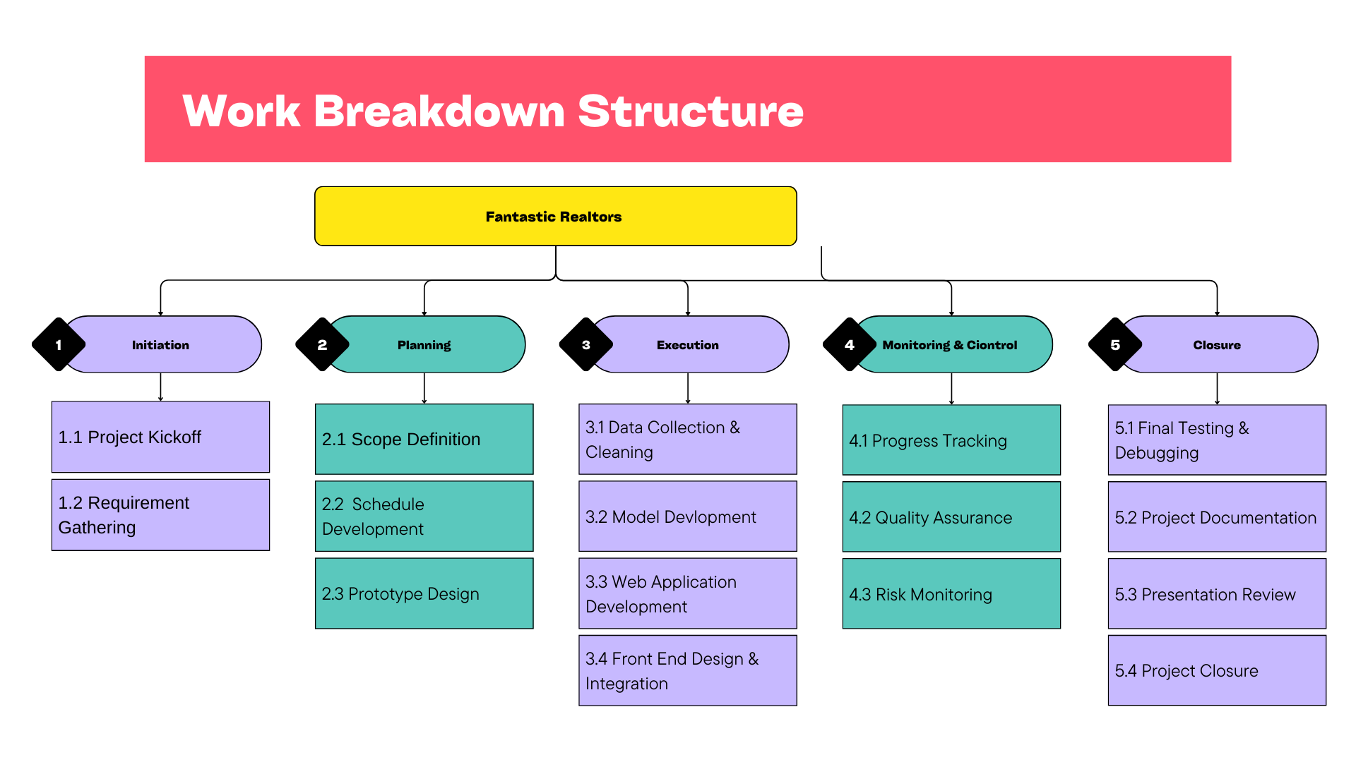Fig 1. WBS diagram

### **4.3 WBS Dictionary**

**1. Initiation**

* **1.1 Project Kickoff**
  + **Description:** The initial meeting where the project team and stakeholders come together to discuss the project's objectives, deliverables, timeline, and overall approach.
  + **Key Deliverables:** Project charter, initial project plan, stakeholder list.
* **1.2 Requirement Gathering**
  + **Description: The process of collecting and documenting the functional and non-functional requirements from stakeholders to define the project's scope and objectives.**
  + **Key Deliverables:** Requirement specifications document, stakeholder requirements.

**2. Planning**

* **2.1 Scope Definition**
  + **Description: The process of defining the project's scope, including deliverables, objectives, and boundaries.**
  + **Key Deliverables:** Scope statement, work breakdown structure (WBS).
* **2.2 Schedule Development**
  + **Description:** The creation of a detailed timeline for the project, outlining the start and end dates for each task and milestone.
  + **Key Deliverables:** Project schedule, Gantt chart.
* **2.3 Prototype Design**
  + **Description:** The development of initial design mockups or prototypes to visualize the project's deliverables, particularly the web application interface.
  + **Key Deliverables:** Prototype models, design specifications.

**3. Execution**

* **3.1 Data Collection & Cleaning**
  + **Description:** The process of gathering relevant data for the project and cleaning it to ensure accuracy and completeness for the machine learning model.
  + **Key Deliverables:** Cleaned and formatted dataset, data collection report.
* **3.2 Model Development**
  + **Description:** The process of developing the machine learning model using the collected data to predict housing prices.
  + **Key Deliverables:** Trained machine learning model, model evaluation report.
* **3.3 Web Application Development**
  + **Description:** The development of a web application that allows users to interact with the machine learning model and view predictions and visualizations.
  + **Key Deliverables:** Functional web application, user interface design.
* **3.4 Front End Design & Integration**
  + **Description:** The design and integration of the front-end components of the web application, ensuring a smooth and intuitive user experience.
  + **Key Deliverables:** Integrated front-end interface, user experience report.

**4. Monitoring & Control**

* **4.1 Progress Tracking**
  + **Description:** The ongoing process of monitoring project progress against the planned schedule and adjusting as necessary.
  + **Key Deliverables:** Progress reports, updated project schedule.
* **4.2 Quality Assurance**
  + **Description:** The process of ensuring that the project deliverables meet the required quality standards.
  + **Key Deliverables:** Quality assurance plan, test results.
* **4.3 Risk Monitoring**
  + **Description:** The ongoing identification, analysis, and mitigation of risks that could impact the project’s success.
  + **Key Deliverables:** Risk management plan, risk register updates.

**5. Closure**

* **5.1 Final Testing & Debugging**
  + **Description:** The final phase of testing and debugging the web application to ensure it functions as expected before deployment.
  + **Key Deliverables:** Test reports, bug fixes.
* **5.2 Project Documentation**
  + **Description:** The creation of comprehensive documentation for the project, including design documents, user manuals, and technical specifications.
  + **Key Deliverables:** Final project documentation, user manual.
* **5.3 Presentation Review**
  + **Description:** The preparation and review of the project presentation, including a review of the key findings, results, and final deliverables.
  + **Key Deliverables:** Project presentation, presentation review feedback.
* **5.4 Project Closure**
  + **Description:** The final phase where the project is formally closed, and all project deliverables are handed over to the client or stakeholders.
  + **Key Deliverables:** Project closure report, client handover.

## **5. Time Management**

### **5.1 Gantt Chart**

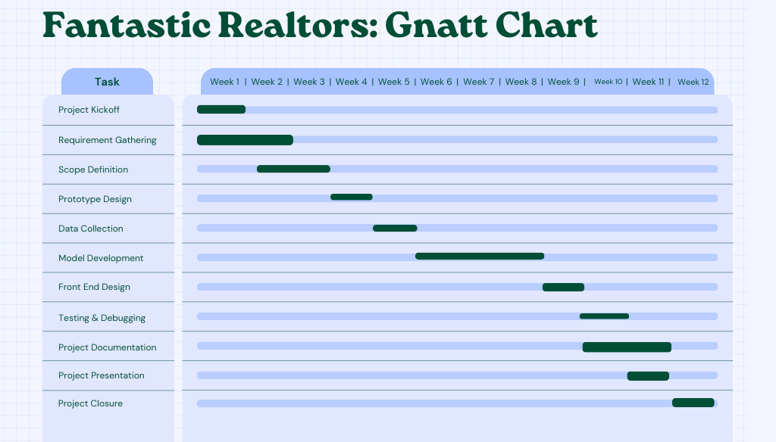Fig 2. Gnatt Chart [2]

### **5.2 Development Schedule**

* **Week 1-2**: Project Kickoff, Stakeholder Identification, and Requirement Gathering.
* **Week 2-3**: Define project scope, finalize WBS, and create the Gantt Chart.
* **Week 4-5**: Data Collection, Prototype Design.
* **Week 6-8**: Model Development, Web Application Development.
* **Week 9-10**: Front-End Design, Integration, Quality Assurance, Testing and Debugging.
* **Week 10-12**: Final Testing, Documentation, Presentation, and Project Closure.

## **6. Risk Management**

### **6.1 Risk Register**

|  |  |  |  |
| --- | --- | --- | --- |
| **Risk** | **Likelihood** | **Impact** | **Mitigation Strategy** |
| Data Availability Issues | Medium | Medium | Locate various data sources and maintain alternative datasets. |
| Model Accuracy Concerns | Low | Medium | An iterative evaluation of models and adjustment. |
| Development Delays | Low | Medium | Conduct regular progress evaluations and change the timeline as appropriate. |
| Security Vulnerabilities | Medium | High | Implement protection standards and conduct frequent assessments. |

### **6.2 Risk Mitigation Plan**

* **Data Availability Issues**: Manage backup datasets and check the integrity of data early in the project.
* **Model Accuracy Concerns**: Cross-validation and hyperparameter adjustment can increase the precision of models. [5]
* **Development Delays**: Divide work into smaller, more manageable parts and track progress regularly.
* **Security Vulnerabilities**: Incorporate security checks across the development procedure and carry out testing.

## **7. Monitor and Control**

### **7.1 Change Control log**

A change control log is a table filled-out with the record of all the change requests which allows for better informed decisions within the project as it involves all the details of the requests which include the following:

1. Change ID: Change request ID which is unique to the request
2. Description: Summary of the request
3. Requestor: The person who made the request
4. Date submitted: The date the request was submitted for review
5. Status: Status of the request whether it was approved or rejected
6. Impact Analysis: A summary on how it affects the project
7. Decision: Weather it was approved or rejected
8. Comments: Additional information about the change request

|  |  |  |  |  |  |  |  |
| --- | --- | --- | --- | --- | --- | --- | --- |
| Change Req ID | Date submitted | Change Desc | Requestor | Impact summary | status | Decision | notes |
| CR-001 | 2024-08-17 | Adjustment in non - Functional requirement | Anthony | Minor Impact on schedule | Implemented | Approved | Re-evaluate in next phase |
| CR-002 | 2024-08-19 | Adjusting Gnatt Chart | Chayan | Minor delay, no changes in scope or budget | Implemented | Approved | Making it more readable, communicate it to the team |
| CR-003 | 2024-08-22 | Ai search tool feature on website | Dave | Major schedule delays, | Pending | --- | Re-evaluate in next phase |
| CR-004 | 2024-08-22 | Additional website features | Anthony | Major schedule delay | Rejected | Rejected | Too time consuming |
| CR-005 | 2024-08-23 | Adjusting WBS | Chayan | Slight delay, | Implemented | Approved | Update project plan visually easier to read |

### **7.2 Change Control Board**

Definition: A Change Control board is a group of stakeholders responsible for reviewing, evaluating, approving, or rejecting and changing a project. These requests are reviewed on their impact on the project's scope, schedule, budget, and quality which allows for only the favorable changes to be implemented.

Purpose:

* Alleviate risk of potentially negative changes to the project
* Ensuring changes align with project outlines such as scope, budget and timeline

## 8. Project Closure

### **8.1 Acceptance Criteria**

**Given** I'm not logged in, I will start at the sign up / login page **When** entering a valid user/pass **then** it will log me in.

**Given** you are on the main page after logging in **When** the user presents a prompt to the ai **Then** the ai will generate a response.

**Given** you on the main page **When** you ask the ai for a price of a house with a specific location, house type, etc. **Then** the ai will predict the housing price.

**Given** you are on the first page **When** you click on the contact information page **Then** the information about the group members will be there with their emails.

**Given** I have the loan amount, interest rate and the repayment period **When** i input these variables into the calculator **Then** it will print out the estimated mortgage payment per week, fortnight, or month even.

**Given** I have data on housing prices in multiple different areas **When** the user selects or types an area **Then** the average price of the houses in that area is displayed

**Given** multiple houses in a certain area **When** the user uses and adjusts the slider to represent the price range, they’re looking for **Then** all the properties within that price range will be displayed

**Given** a list of multiple houses **When** the user presses the bookmark button next to a certain property **Then** the website saves the users bookmarked house in case the user wants to look at it later.

## **9. Project Design**

### **9.1 Front-End Prototype**

Fig 3. Front page prototype

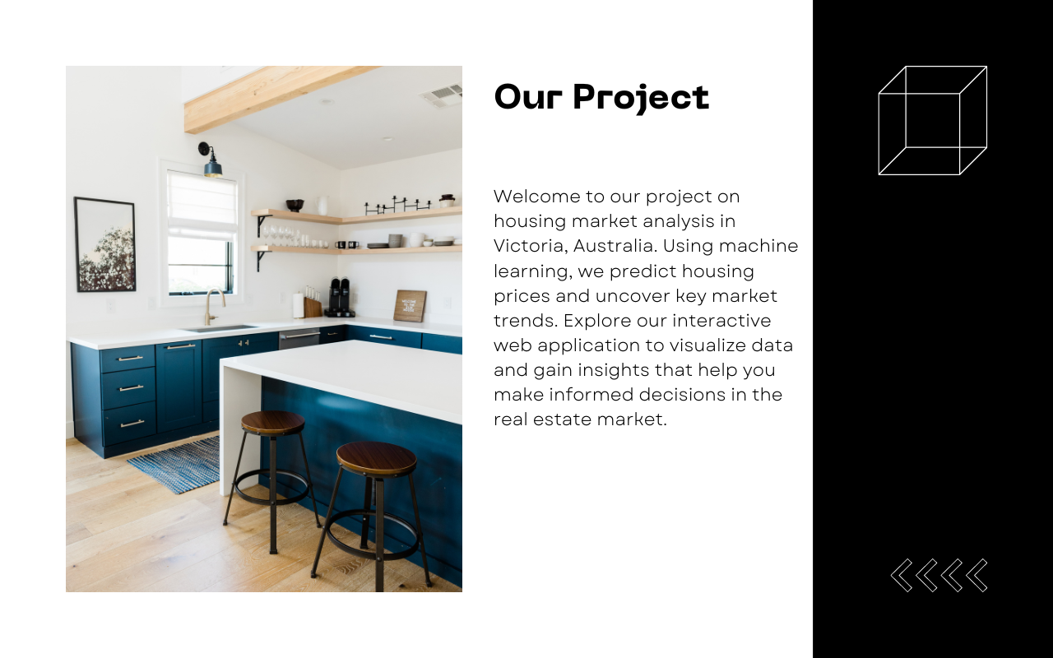Fig 4. What our project/website is about

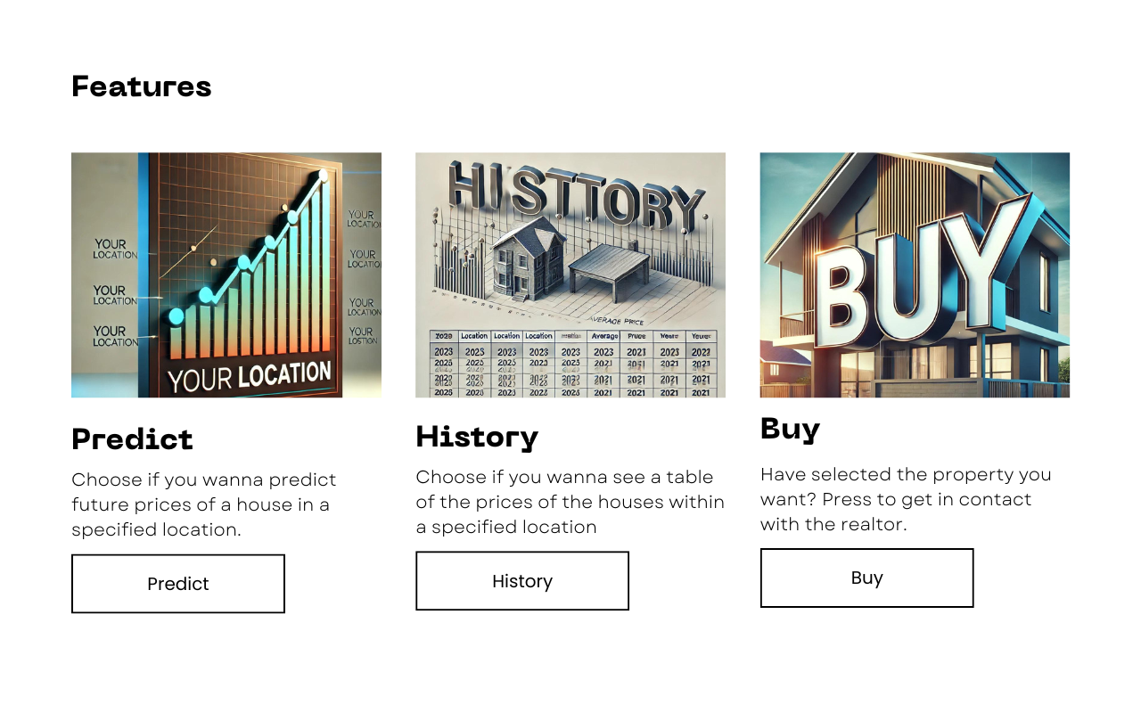Fig 5. Features page prototype

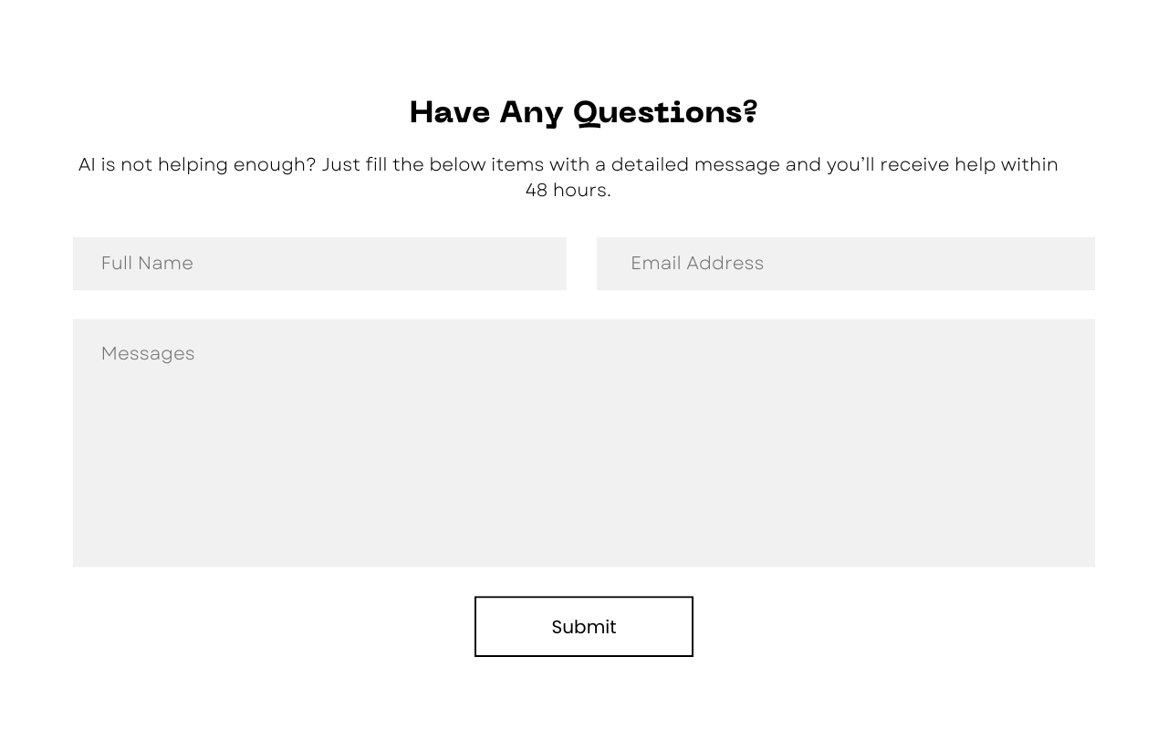Fig 6. Help page prototype

### **9.2 Usability Principles**

* **Visibility of System Status:**

The website provides users with a large majority of buttons that make it clear what action is to happen next to keep them informed additionally the many buttons such as the “Get Started” promptly moves them into our features page which would be appropriate feedback within a reasonable time.

* **Match Between System and the Real World:**

The website has many similarities to the real-world including the terminology of the website using words such as “Predict”, “History”, and “Buy” which are all used in real world real estate.

* **User Control and Freedom:**

At the top of every single webpage, it has a navigation bar which allows the user to have the freedom to navigate between all the pages at any time and avoid getting stuck and feeling frustrated.

* **Consistency and Standards:**

The website is made to be very consistent throughout all the webpages, so it doesn’t fail user expectations. An example can be made of the website’s color palette as it stays consistent of mainly neutral colors such as black, grey and white. The font also stays consistent between the pages and even the buttons.

* **Error Prevention:**

For error prevention we included a form asking if the user needs any help, and even in that form the boxes are filled out with the specific information we need to prevent users from putting the wrong information in each box.

* **Recognition Rather Than Recall:**

Using terminology from the real world helps users recognize a features intention, for example “Predict”, if people are going on the website for something related to real estate, they would recognize the word “Predict” to be something in relation to the prediction of housing prices.

* **Flexibility and Efficiency of Use:**

The design is both for inexperienced and experienced users as the whole website design is simple, as if they get lost on the home page our website has the “Get Started” button which will directly navigate them to the features of the website.

* **Aesthetic and Minimalist Design:**

The design avoids a lot of unnecessary clutter as most of the designs are catered to the large buttons on the screen which make it almost unavoidable for users. In addition, it has information next to the button to pinpoint what the button does.

* **Help and Documentation:**

The website includes a help section which has a simple form for users that need help.

# References

[1] Case, K. E., Quigley, J. M., & Shiller, R. J. (2013). Wealth effects revisited 1978-2009. *National Bureau of Economic Research*.

[2] Goodman, A. C., & Thibodeau, T. G. (2008). Where are the speculative bubbles in US housing markets? *Journal of Housing Economics*, 17(2), 117-137

[3] Grimes, A., & Aitken, A. (2010). Housing Supply, Land Costs and Price Adjustment. *Real Estate Economics*, 38(2), 325-353.

[4] Hilber, C. A. L., & Vermeulen, W. (2016). The impact of supply constraints on house prices in England. *The Economic Journal*, 126(591), 358-405.

[5] Wilson, J.M., 2003. Gantt charts: A centenary appreciation. European Journal of Operational Research, 149(2), pp.430-437.